- Convert the following algorithm into a program and find its time complexity using the counter method.
void function (int n)
{
int i= 1;
int s =1;
while(s <= n)
{
i++;
s += i;
}
}
Note: No need of counter increment for declarations and scanf() and count variable printf() statements.
Input:
A positive Integer n
Output:
Print the value of the counter variable

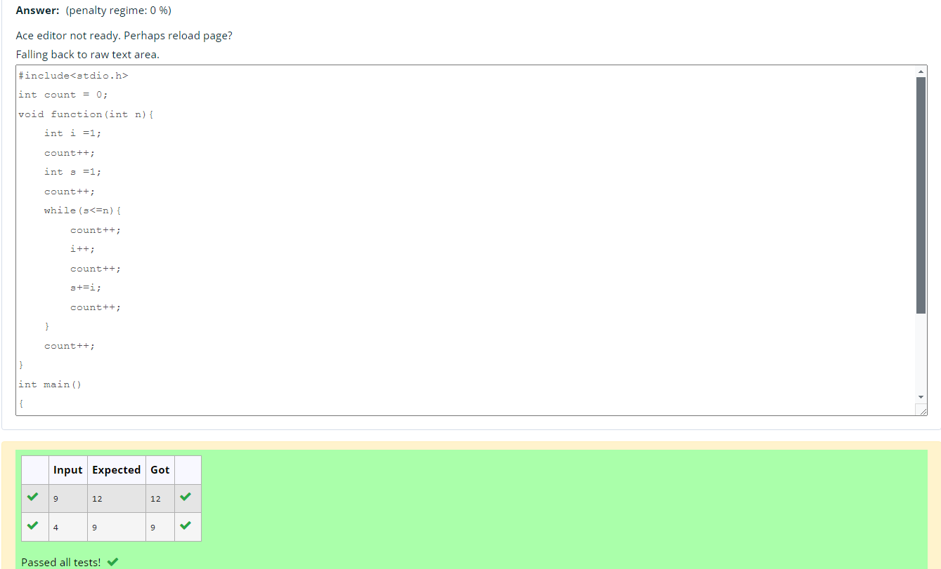
- Convert the following algorithm into a program and find its time complexity using the counter method.
void func(int n)
{
if(n==1)
{
printf("*");
}
else
{
for(int i=1; i<=n; i++)
{
for(int j=1; j<=n; j++)
{
printf("*");
printf("*");
break;
}
}
}
}

Note: No need of counter increment for declarations and scanf() and count variable printf() statements.
Input:
A positive Integer n
Output:
Print the value of the counter variable

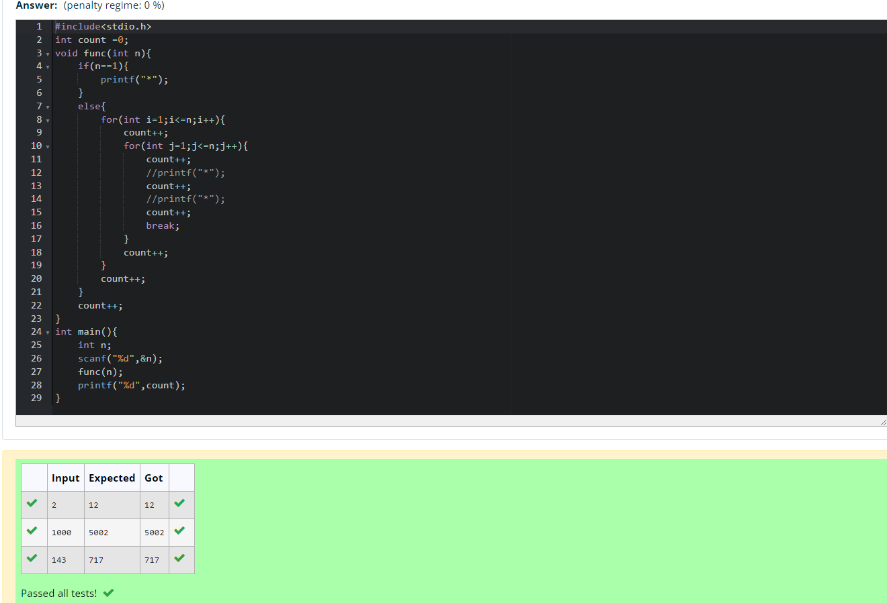

- Convert the following algorithm into a program and find its time complexity using counter method.
Factor(num) {
{
for (i = 1; i <= num;++i)
{
if (num % i== 0)
{
printf("%d ", i);
}
}
}
Note: No need of counter increment for declarations and scanf() and counter variable printf() statement.
Input:
A positive Integer n
Output:
Print the value of the counter variable

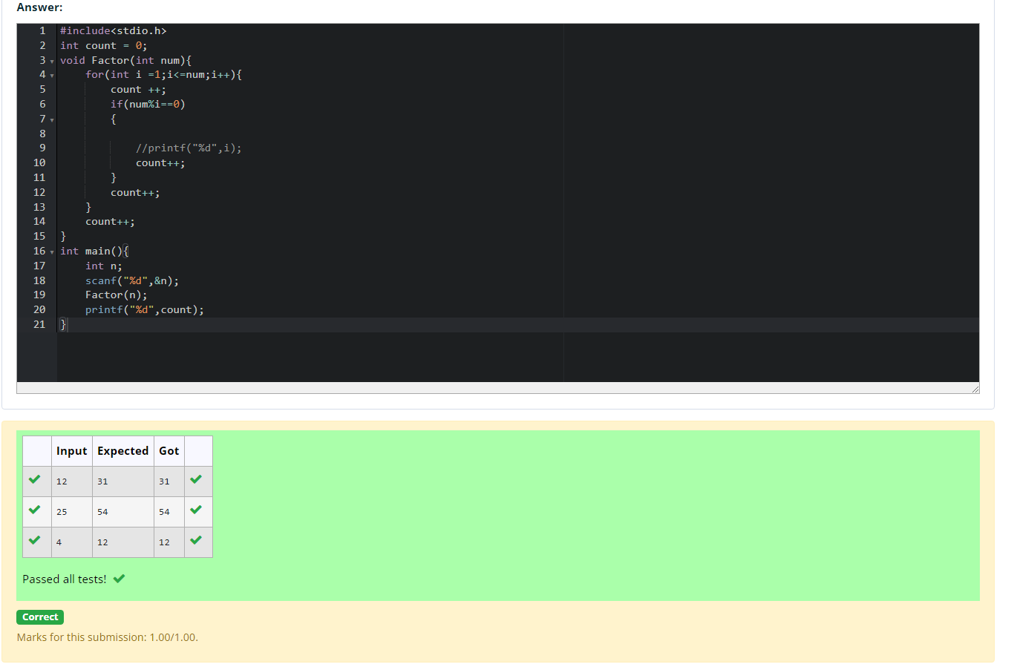

- Convert the following algorithm into a program and find its time
complexity using counter method.
void function(int n)
{
int c= 0;
for(int i=n/2; i<n; i++)
for(int j=1; j<n; j = 2 * j)
for(int k=1; k<n; k = k * 2)
c++;
}
Note: No need of counter increment for declarations and scanf() and count variable printf() statements.
Input:
A positive Integer n
Output:
Print the value of the counter variable

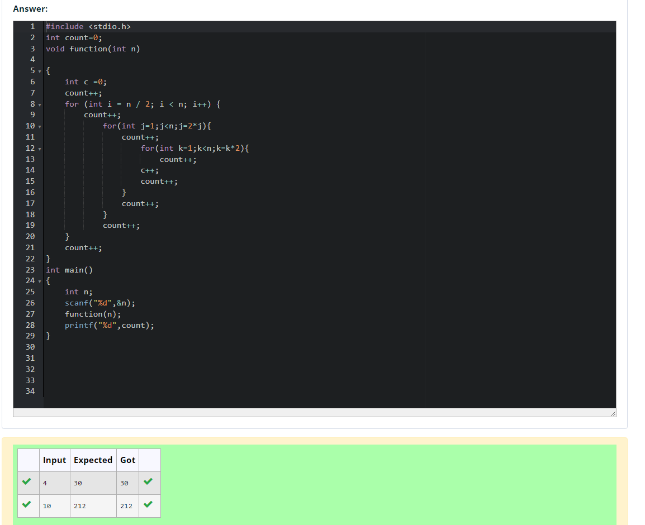

- Convert the following algorithm into a program and find its time complexity using counter method.
void reverse(int n)
{
int rev = 0, remainder;
while (n != 0)
{
remainder = n % 10;
rev = rev * 10 + remainder;
n/= 10;
}
print(rev);
}
Note: No need of counter increment for declarations and scanf() and count variable printf() statements.
Input:
A positive Integer n
Output:
Print the value of the counter variable

